**Border Patrolling Multifunctional Robot**

Installation Guide

**Software Setup**

1. Install Rasbian to your SD card and connect the raspberry pi to laptop using Ethernet.
2. Making a wireless connection of Raspberry Pi 3 B+ with laptop.
3. Provide raspberry pi to your wifi name and password

‘Sudo nano /etc/wpa_supplicant/wapa_supplicant.conf’

Add the following text

network={

ssid=”your wifi name”

psk=”password”

key_mgmt=WPA-PSK

}

Press **Ctr+O** to save and then **Ctr+X** to exit. Restart your Pi.

1. Open browser and type the ip address of your modem and find the list of connected device.
2. Copy the ip address of raspberry pi.
3. Paste the ip address to VNC VIEWER.
4. Enter the credentials.
5. Configure Webcam
6. Type in the command '**sudo apt-get install motion** ' to start the installation.
7. Type in the command '**lsusb**' and enter. You should see the name of your camera. If it is NOT there, then there is **some problem** in your camera or the camera is **not supported in 'motion'**.
8. After the installation is complete, type in the command ' **sudo nano /etc/motion/motion.conf** ' and press enter.
9. Make sure 'daemon' is ON.
10. Set 'framerate' anywhere in between 1000 to 1500.
11. Keep 'Stream_port' to 8081.
12. 'Stream_quality' should be 100.
13. Change 'Stream_localhost' to OFF.
14. Change 'webcontrol_localhost' to OFF.
15. Set 'quality' to 100.
16. Set 'width' & 'height' to 640 & 480.
17. Set 'post_capture' to 5.
18. Press ctrl + x to exit. Type ‘y’ to save and enter to confirm.
19. Again type in the command '**sudo nano /etc/default/motion '**and press **enter**.
20. Set **' start_motion_daemon '**to **yes.**Save and exit.

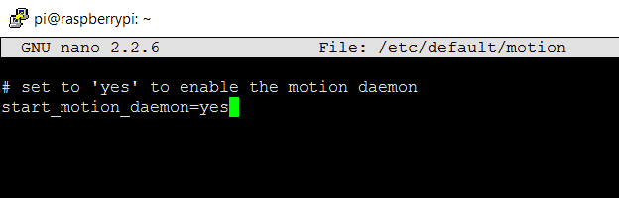

### Flask Setup in Raspberry Pi for Controlling Robot through Webpage.

### Flask is a micro framework of python used to run python scripts from a web page and to make a web server

### Sudo pip install flask

1. Install Adafruit library for Temperature and Humidity sensor
2. Type the following command

git clone <https://github.com/adafruit/Adafruit_Python_DHT.git>

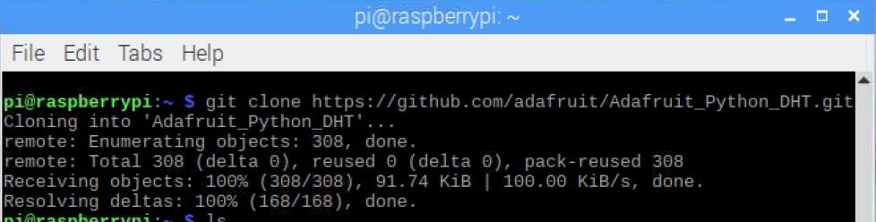

1. cd ADAfruit_Python_DHT
2. sudo python setup.py install

**Hardware Setup**

1. **DC Motor to Raspberry pi by L298N motor driver**:

GPIO pins from Raspberry pi will be connected to IN1, IN2, IN3, IN4 of L298N motor driver. DC Motor will be connected to their respective left and right out ports and 5 volts supply from Raspberry pi will be given to L298N driver. The ground pins from Raspberry pi will be connected to L298N ground pins.

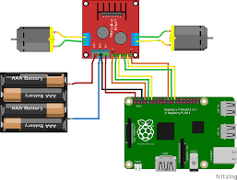

1. **USB Webcam to Raspberry pi**:

The USB Webcam will be connected to USB port of Raspberry pi.

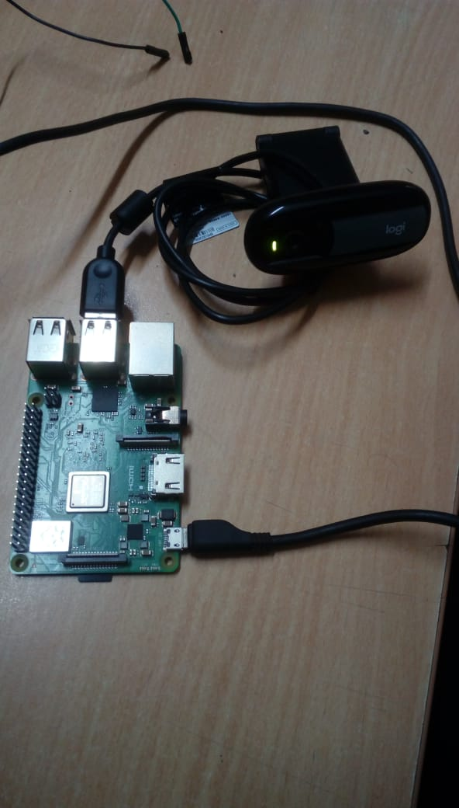

1. **Ultrasonic to raspberry pi**:

The Vcc and ground pins of Ultrasonic sensor will be connected to 5 volts and ground pins of Raspberry pi. The Trigger and echo pins will be connected to GPIO pins of Raspberry pi.

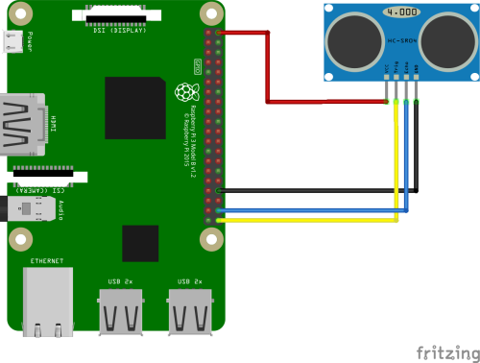

1. PIR to Raspberry pi:

The ground pin and Vcc will be connected to 5 volts and ground pin of Raspberry pi through bread board. The data pin of PIR sensor will be connected to GPIO pin.

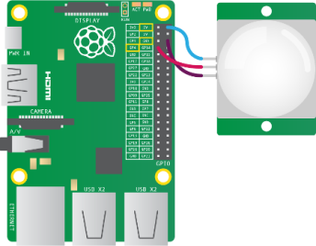

1. Temperature and humidity Sensor to Raspberry pi:

The ground pin and Vcc pin will be connected to 5 volts and ground pin of Raspberry pi through bread board. The pin will be connected to Raspberry pi.

